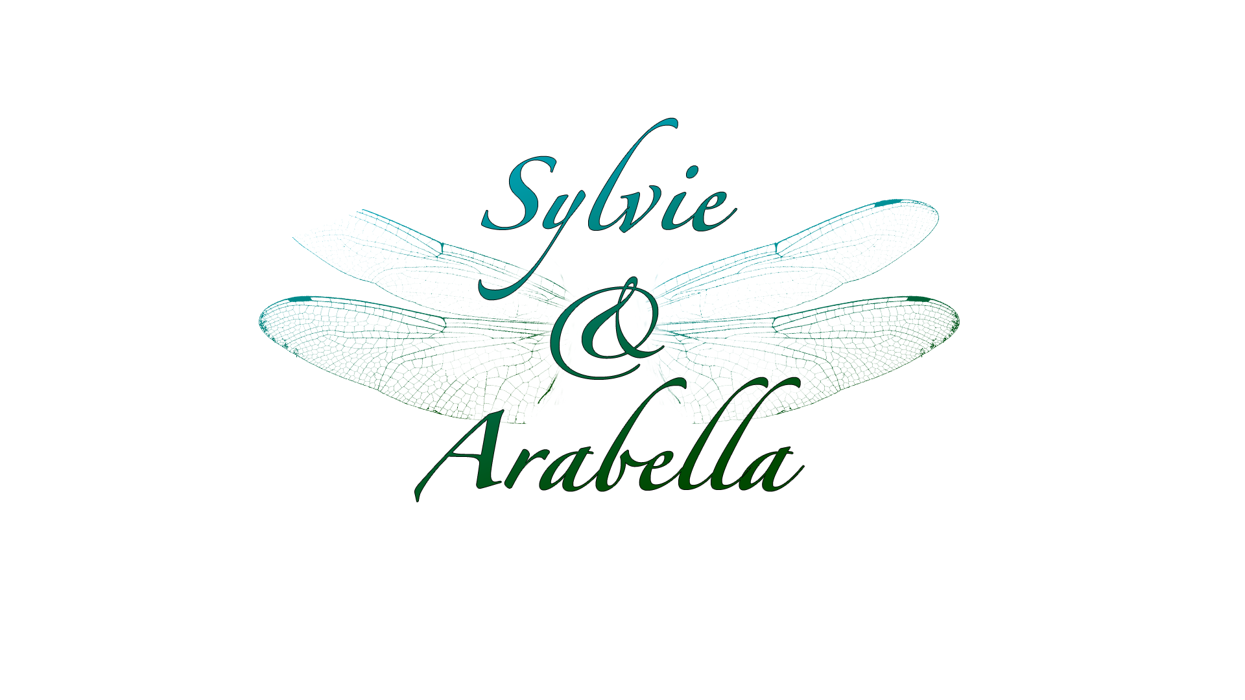
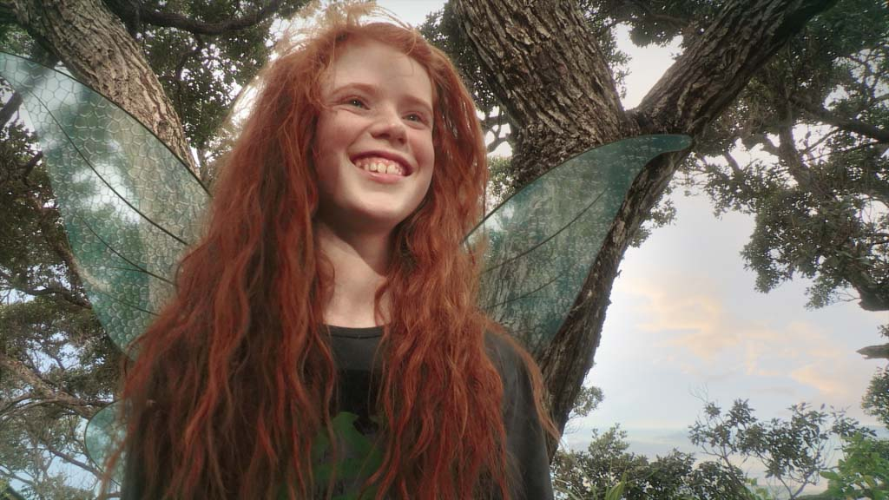

One girl, one fairy, one extraordinary friendship.
A mesmerising tale of childhood love and adventure.

Genre/format: Television series for primary school children – 13 x half- hour episodes. Live action + potential for elements of computer generated imagery / animation
Target market: Children 6 - 11 / Family market
Filming: Singapore for the human world; New Zealand for the fairy world.
Wider project elements include: Screen productions (TV series & 3d feature), Transmedia, Educational Resources
Seeking:
◆ Development funding for research, scripts, location, casting, legal contracts
◆ A co-production partnership

Imagine if you were a child, and your best friend was very unusual fairy!
And, what if she came from a breath-takingly strange and beautiful place, full of extraordinary characters, and adventure?
Now, imagine you could go there, too…

Sylvie & Arabella is going to do for fairies, what Twilight did, for vampires!
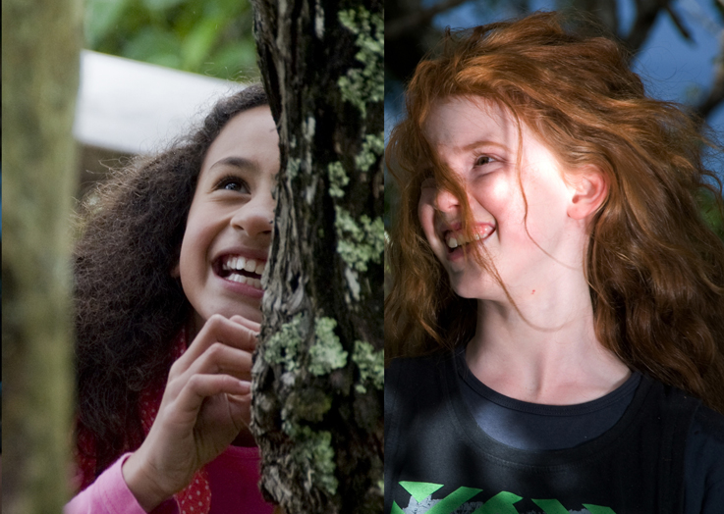
Sylvie and Arabella come from two different worlds. Despite their vastly different personalities, the girls soon become best friends and realise they have a lot to learn from each other; about life, about themselves, and about growing up.
Arabella’s world is RADICALLY different to Sylvie’s pre-conceived notions about fairies, and Arabella is equally flabbergasted by Earth! Each episode focuses on a specific value, and as the girls work to find a solution to the challenges they face, they learn important values-based lessons along the way. They are both in for a riotous ride of adventures, discoveries and challenges…

Core Development Team:
Bridget Ellis-Pegler : Sylvie & Arabella Creator/Principal Writer. Bridget is a scriptwriter with eleven years’ experiences writing scripts for a broad range of productions including popular New Zealand children’s series Party Animals and Suzy’s World. She is a deep believer in children’s ability to appreciate intelligence, beauty and creativity - and this was her motivation for creating Sylvie & Arabella.
Ronel Schodt : Head of Screen Production.
Ronel has extensive experience as a producer in the film and television industry, both in her native South Africa and New Zealand, having worked on countless productions in her twenty-five years in the industry.
Janette Searle : Business Development Manager.
Janette joins the project with a specific focus on developing the transmedia strategy drawing on her broad experience in the screen, music and creative industries.
Contact Details
Business Development Manager: Janette Searle janette@sylvieandarabella.com
P: +64 27 4334978 E: info@sylvieandarabella.com W: www.sylvieandarabella.com

