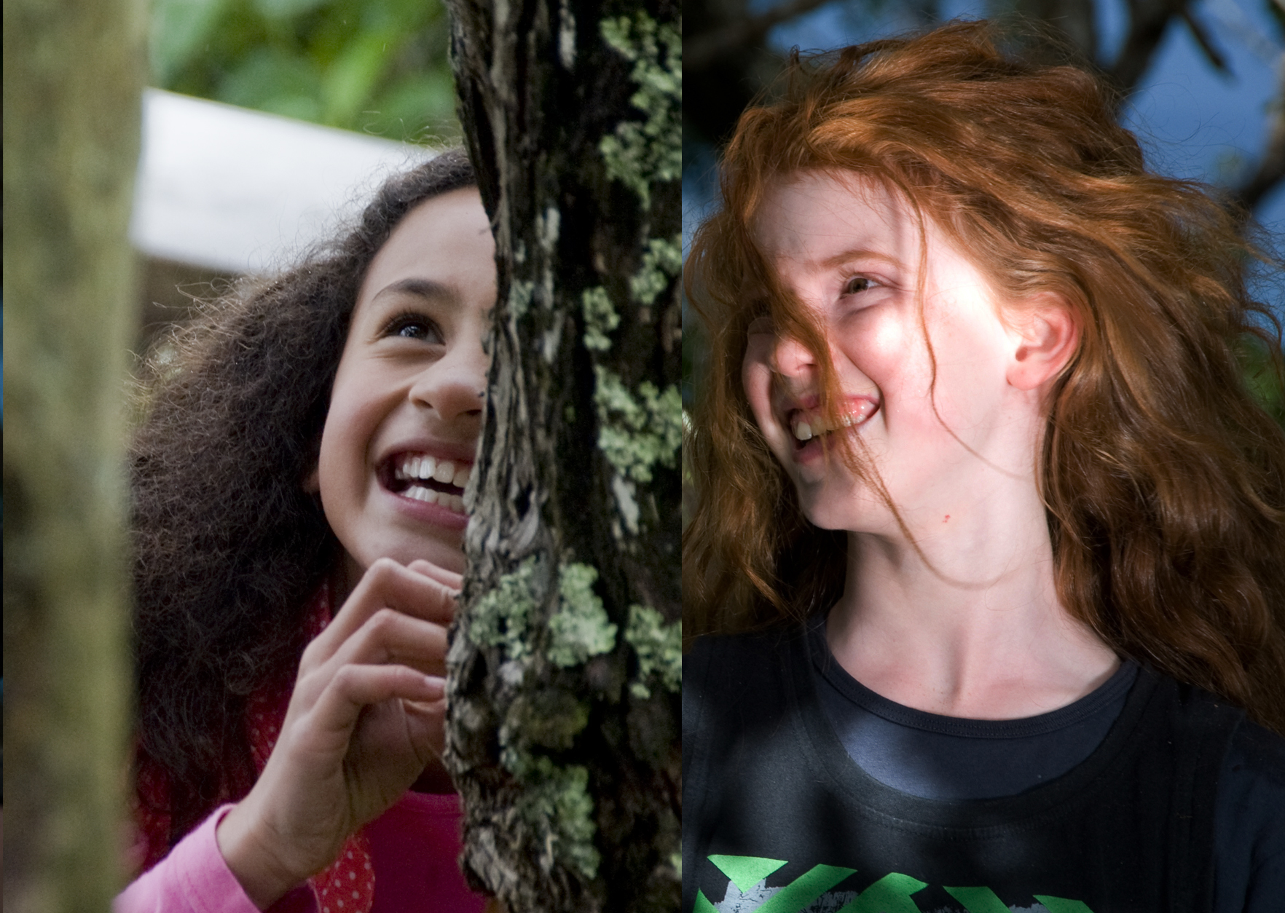
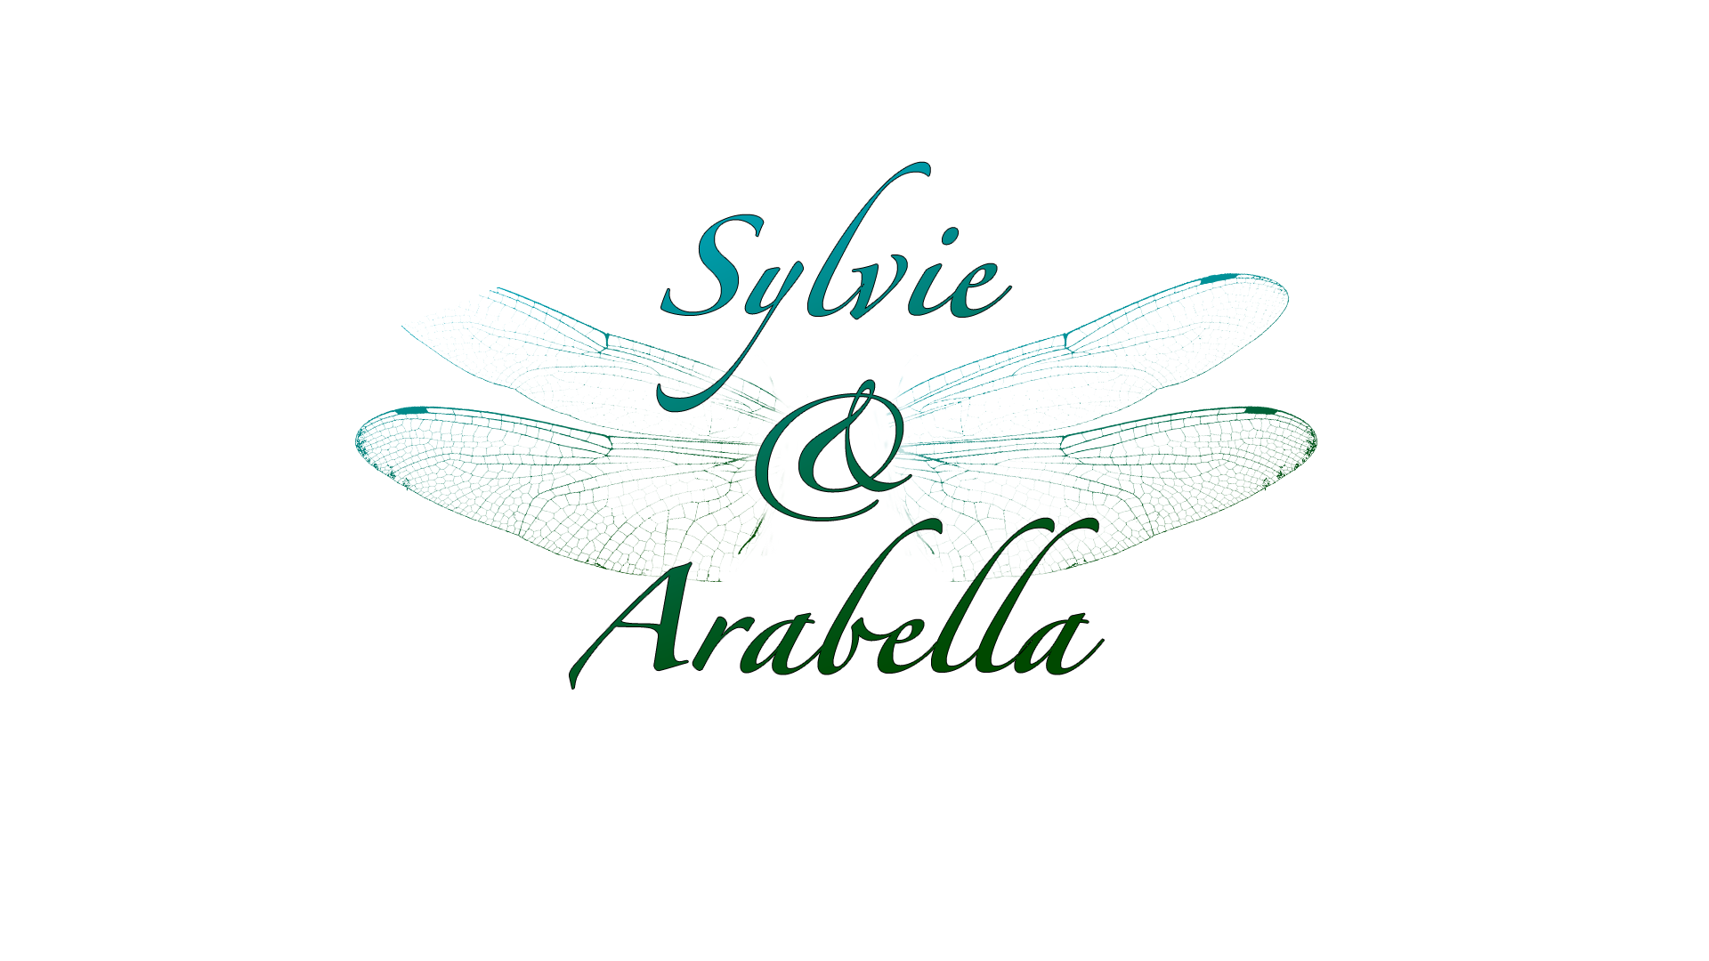

One girl, one fairy, one extraordinary friendship.
A mesmerising tale of childhood love and adventure.

Genre/format: Television series for primary school children – 13 x half- hour episodes. Live action + potential for elements of computer generated imagery / animation
Target market: 6 - 11 Children / Family market
Filming: Singapore for the human world; New Zealand for the fairy world.
Wider project elements include: Screen productions (TV series & 3d feature), Transmedia, Educational Resources
Seeking:
Development funding for research, scripts, location, casting, legal contracts
A co-production partnership

Table of Contents

Series Outline 3
Target Audience 4
Treatment notes 5
Visual Treatment 5
Habitats 6
Sound Design. 6
Longevity 7
Transmedia Strategy 7
Core Development Team: 8

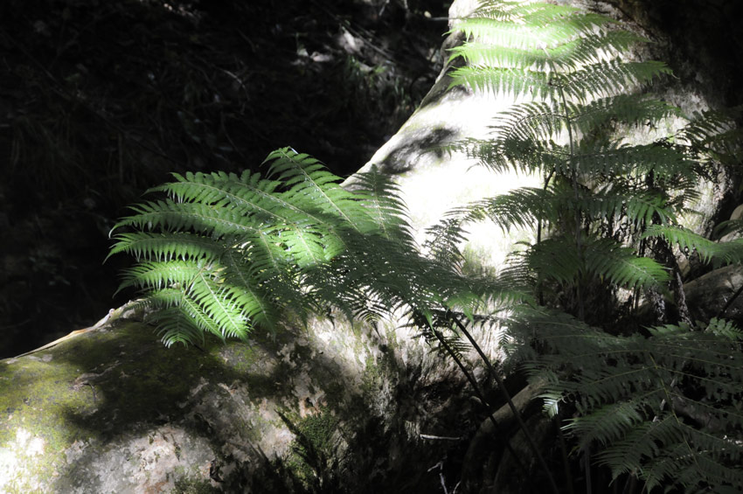
Series Outline
Sylvie’s English-speaking family has recently moved to Singapore. The move is a real culture shock for Sylvie. Everything is so different - it’s exciting, but sometimes overwhelming, too. It’s a big adjustment to life in a condominium with views of skyscrapers, and a small landscaped terrace, after the bungalow and large garden she was used to.
On the plus side, she’s experiencing new things constantly, and gaining confidence as she tackles new challenges. Consequently, Sylvie finds herself in many situations that require her to explore her true self, and what is really important in life. Through the choices she makes, (and making a wish), she gains access to the fairy world, and meets the wonderful fairy, Arabella. Arabella is NOTHING like the prettily dressed fairies of Sylvie’s imagination. With her messy appearance, clumsiness and spontaneity, Arabella’s tomboyish nature is very different to Sylvie’s gentler one. Nonetheless, they have a deep connection and become close friends very quickly.
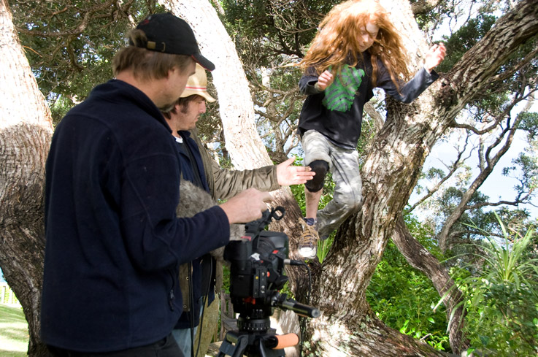

Arabella introduces Sylvie to the fairy community in Serendipity, including her eccentric Aunt Kate, and Elspeth, the spiky-haired, guinea-pig-loving fairy queen. Sylvie is mesmerised by the innovative design of the fairies’ buildings and public spaces, their progressive ideas about the environment, the fantastic characters she meets, and by the natural beauty of their world.
It’s all utterly enchanting. Nonetheless, Sylvie is astonished to find that most of her pre-conceived ideas about the world of fairies are far from reality. She had always imagined it would be as it is portrayed in storybooks, with fairies skipping around toadstools and sipping dew out of flowers. She never imagined that fairies would hold down corporate jobs, shop at the supermarket, attend school, or that they would use mobile phones or computers! Arabella’s notions about the human world are equally confused. So, both girls are in for an epic voyage of discovery.
It transpires that Sylvie’s access to Serendipity relates to the way she makes her choices in life. Sylvie demonstrates a willingness to try and do the right thing when faced with options. She might not always succeed, and she doesn’t always make the best choice first, but the important thing about Sylvie is her openness to trying. This is a very important quality which she shares with Arabella, and is the reason that Fate (in the guise of Queen Esther) has brought them together. Sylvie learns that she can come to Serendipity whenever she likes, as long as she and Arabella continue this quest, and share and learn together in the process. They share magnificent adventures together, not only in the fairy world, but in the human world, too, and learn all sorts of fantastic value-related lessons along the way.

Target Audience
Our target audience is 7 – 9 year olds. This is an exciting developmental stage, when children begin to explore life with a degree of independence. They look for adventure with their friends and invent complex fantasy words for their games. They are branching out and exploring who they are. They are also able to understand the more complex and subtle storylines of a series like Sylvie & Arabella.
Although targeting 7-9 year olds, we believe this series will draw quite widely from 6-11 year olds. For the younger audience, the broad and obvious story lines and characters are all appropriate and the characters and scenery will enchant. For the older audience the complexity of the story and the adventure will appeal.
Children in this age group talk about what they see, hear, and love, to their friends and families. Although targeted at 7 – 9 year olds, Sylvie and Arabella is actually a series that has the potential to bring the whole family together.
The transmedia strategy will both satisfy and stretch the expectations of our audience to be able to engage with the series through other media. It will provide an opportunity for participation, interaction, learning and entertainment beyond the television screen that will encourage them to keep watching each episode.

Treatment notes
The treatment outlined here will be used as the basis for all of the elements of the project where appropriate, to create a visual and tonal link across the whole brand.

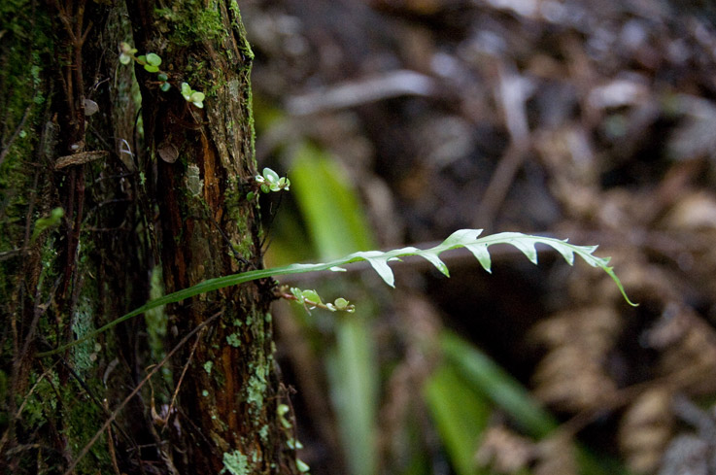
Visual Treatment
Visually Sylvie & Arabella is rich and magical. This relates to both the real world and fairy world, in terms of colour, grade, and movement. We are aiming for a cinematic feel to the way it is shot and how the visuals are treated. While the real world is a cityscape, full of grey enclosing concrete, it is not a drab grey. This is a grey that acts as a backdrop allowing the lights, movement and hustle of the city to flow.

These two settings have many similarities when you look a little closer, despite their apparent differences. This subtle difference will be a common thread throughout the project, including the visual treatment, as it enhances the underlying storyline that on the surface things can look different, but if you look a little harder or more open-mindedly, things are often not as different as they seem.

On Serendipity, the colour palette is full of beautiful muted 'dusky' pastels, such as tea rose pink, moss green, dusty cornflower blue, burnt sienna orange. There is a barely-there silver aspect which is only sometimes apparent, and exceptionally lovely.

The lighting will be textured, dappled, layered, complex and breath-takingly beautiful. There will be lots of shadows, silhouettes and reflections, subtly creating a sense of mystery and intrigue. These slight but important differences will create a clear demarcation between the worlds. It is the very fact that Serendipity is so similar to our world – and yet so different – that makes it so intriguing.

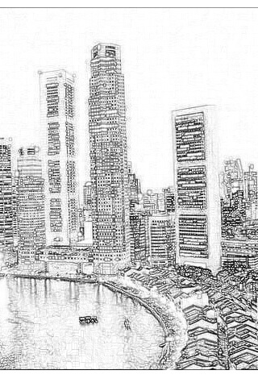
We are also aiming to provide an overall Sylvie &Arabella ‘look’ that will become integral to the brand. So this palette of colours and tones will be consistent across the series. For example a silvery glimmer will be used on the wings and subtly in other aspects, and will weave its way through the fairy world and be used in the real world/city as the series progresses, as a way of showing the development of the longer story lines - that magic can exist at home in the real world as well, if you just know how to see it.

Habitats

The human side of our story takes place in Singapore. Sylvie’s lawyer father has recently been seconded there for work and the family has moved there for the duration of his contract. This exciting multicultural city is an urban jungle with a very dense population, skyscrapers, traffic jams and a fast-paced lifestyle. Singapore offers a setting that enhances the normal challenges we all face, and provides the important culture shock element of our story.

Conversely, Serendipity is sparsely populated with beautiful Nature to be seen at every turn. This series is based in Zillery, one of the countries in Serendipity’s northern hemisphere. Zillery contains a lot of very raw and spectacular scenery. Its capital, Sapphire, has very creative architecture, and unique and beautiful public spaces filled with unusual and thought-provoking sculptures.

Apart from its physical setting, on the surface Serendipity seems similar to the human world, except that everyone living there has wings, and magic is commonplace. Rather than the usual floaty pastel garments, these fairies wear jeans and t-shirts, bathing suits, school uniforms and business suits - standard human clothing, in other words – except, with wings! Arabella’s world is whimsical and wild, synonymous with our own native landscapes in New Zealand. Just the place for children’s adventures! The rawness of our natural light, combined with our beautiful bush and other-worldly landscapes, will create a vastly different world to the high-rise, tungsten lit metropolis of Singapore.

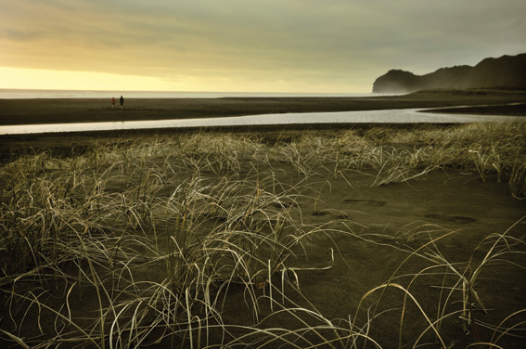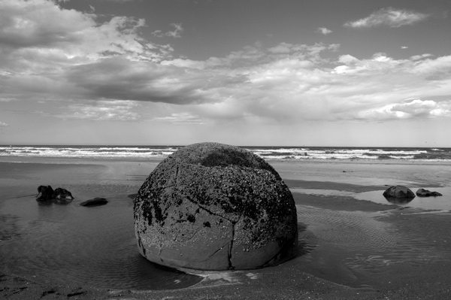

Sound Design.
Sylvie & Arabella’s soundtrack is an important integral aspect of the concept for the series, and as such, will be highly distinctive and unique. There will be specific sounds which the Sylvie & Arabella brand will ‘own’ (e.g. the whirring-purring noise of a fairy flying). There will also be a musical soundtrack which will strongly appeal to adults, as well as children. The overall sound design will be quirky and highly original. Consequently, the audio element of the Sylvie & Arabella brand will be as distinctive as its unique visual element.

Longevity
This is a three-tiered premise with real potential for longevity as a television series (and beyond, e.g. feature film). Each episode contains a challenge. Each season of the series contains an over-riding mission. And finally, the girls have an ultimate quest, which spans several seasons of the series.

Transmedia Strategy

Our target audience is growing up in a world where it is the norm for its visual entertainment to be accessed in a wide range of ways. We intend to exceed these expectations with exciting, interactive and age-appropriate options that encourage users to actively participate where possible.

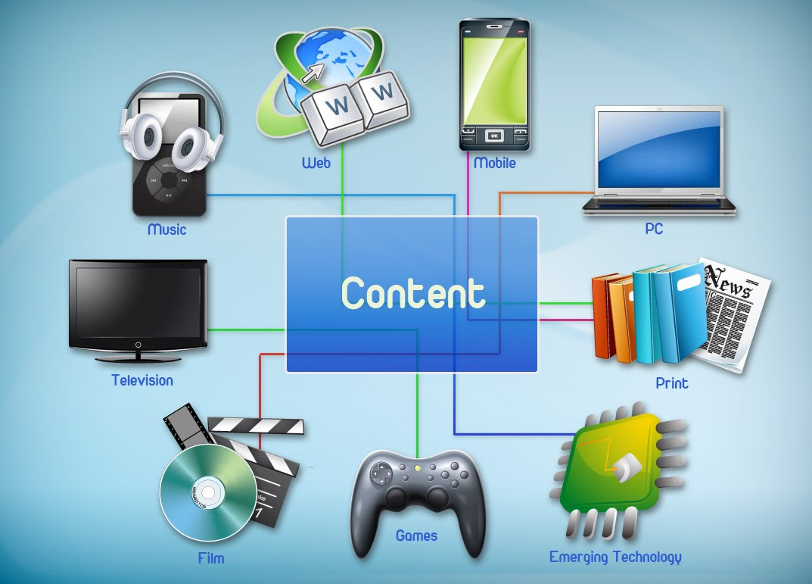
This Transmedia Strategy has been designed to communicate the key value related messages, and an awareness that communication is a two-way street. Below is an outline of the products that will be developed as part of the transmedia strategy and they have been laid out in order of development.

Products that will be developed as part of the Transmedia Strategy:

Website and online series.
Website will host:
- the online series of Webisodes,
- a range of resources (downloadable and online),
- Monitored chat and forum discussion
- Audience contributions (artwork, stories, thoughts)

Social Networking
Carefully monitored social networking applications will be used to communicate with the audience, inform about upcoming news/events – online and real, and find out the challenges they face, and how children overcome them. This sort of supportive and non-judgemental sharing of insights would provide a safe and positive place for children to be online, as well as potentially contributing to our story lines when appropriate.

Digitali

- Phone Apps – for learning and adventure gaming through levels.
- Online Gaming – adventure gaming. The viewer/reader gets to choose where to go next and what to do from the options so that the story is different every time, similar to traditional adventure books.
- Augmented Reality interacting with Real World
  - Using smart phone technology we will bring the real and virtual worlds together to create location specific events, and games.
  - Brand-specific events linked with other brand collateral such as printed posters.
- Competitions e.g. Augmented Reality competitions where participants collect a number of elements from the posters around the location/event to win or upload their prize. Story competitions – encouraging shared experience as an effective and inspirational means of helping others.

Core Development Team:

Bridget Ellis-Pegler : Sylvie & Arabella Creator/Principal Writer. Bridget is a scriptwriter with eleven years’ experiences writing scripts for a broad range of productions including popular New Zealand children’s series Party Animals and Suzy’s World. She is a deep believer in children’s ability to appreciate intelligence, beauty and creativity - and this was her motivation for creating Sylvie & Arabella.

Ronel Schodt : Head of Screen Production.
Ronel has extensive experience as a producer in the film and television industry, both in her native South Africa and New Zealand, having worked on countless productions in her twenty-five years in the industry.

Janette Searle : Business Development Manager.
Janette joins the project with a specific focus on developing the transmedia strategy drawing on her broad experience in the screen, music and creative industries.

We welcome enquiries.

Contact Details
Business Development Manager: Janette Searle janette@sylvieandarabella.com
P: +64 27 4334978 E: info@sylvieandarabella.com
W: www.sylvieandarabella.com

